13.Creating a Virtual Machine Using VMware Workstation
1. Aim
To create and configure a Virtual Machine using Type-2 Virtualization Software (VMware Workstation) with 1 CPU, 2GB RAM and 15GB storage disk.
2. Procedure
- Open VMware Workstation on the host computer.
- Click on Create a New Virtual Machine.
- Select the operating system ISO file (Windows/Linux).
- Enter the Virtual Machine name.
- Open Customize Hardware settings.
- Set the number of processors to 1 CPU.
- Allocate 2GB RAM (2048 MB).
- Create a virtual hard disk with 15GB storage.
- Click Finish to save the VM configuration.
- Click Power On to start the Virtual Machine.
- Install the guest operating system and verify its working.
IMPLEMENTATION
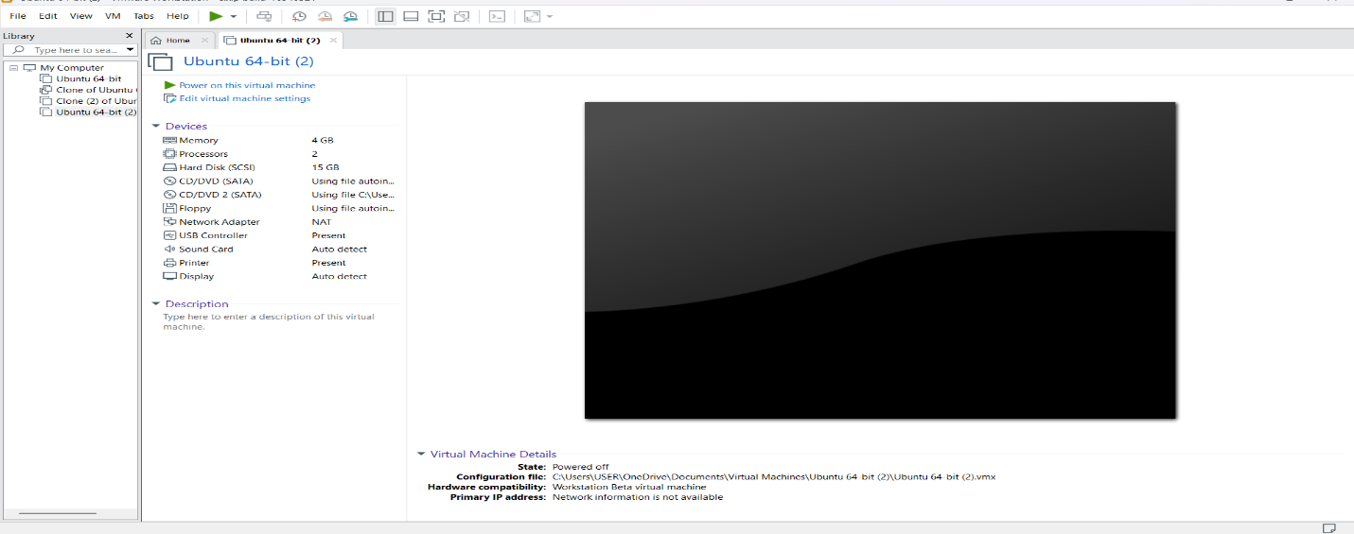
Result :Thus, a Virtual Machine was successfully created using VMware Workstation with 1 CPU, 2GB RAM and 15GB virtual storage disk, demonstrating Type-2 virtualization.

